**Software Quality Engineering**

**(SE-309)**

**ASSIGNMENT 1**

***EXPLORATION OF SOFTWARE TESTING TOOL***

(SELENIUM and POSTMAN)

**Submitted by: AQSA ZAIB**

**Roll no : SE-21013**

**Date: 29/April/2024**

**SELENIUM:**

**Introduction:**

Selenium is an open source testing tool that allows users to test web applications across different browsers and platforms. [Selenium](http://www.seleniumhq.org/) includes a suite of software that developers can use to automate web applications including IDE, RC, WebDriver and Selenium grid, which all serve different purposes

**Use of selenium:**

The uses of Selenium increase as you advance in the suite, and each component has [advantages and disadvantages](http://www.optimusinfo.com/selenium-testing-advantages-and-disadvantages/). The basic fundamentals of Selenium though revolve around browser testing, as developers and testers alike love the open source framework's ability to mimic a real user’s actions in the browser.

What makes Selenium so [easy to learn](http://toolsqa.com/selenium-tutorial/) is its ability to bind to several popular languages, letting you write in your [preferred programming language](https://crossbrowsertesting.com/blog/development/best-programming-language-to-learn-first/) including Java, Javascript, PHP, Perl, C#, Ruby, .Net, and Python.

**Test Cases:**

* **Gmail Login Test**

Code:

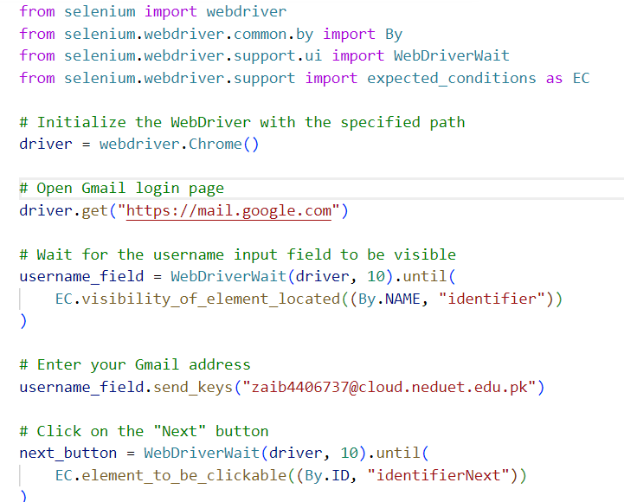

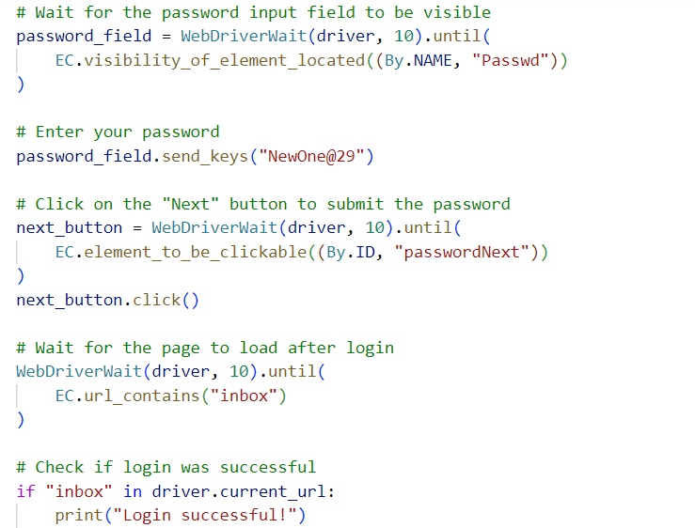



Output:



* **Facebook Login Test**

Code:

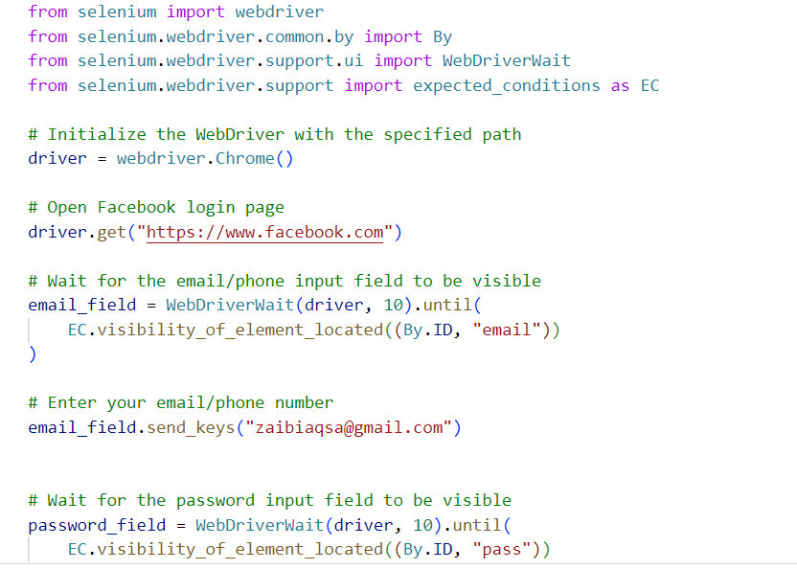

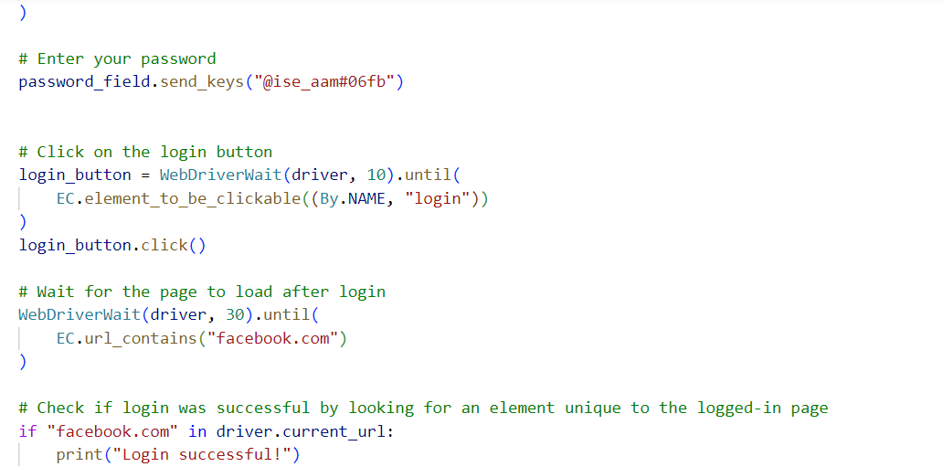

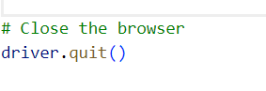

Output:



* **Presence of an element Test**

Code:

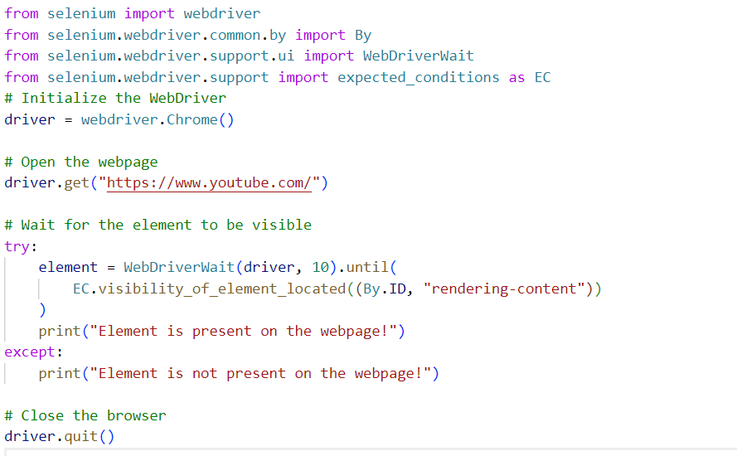

Output:



* **Actual Title Test**

Code:

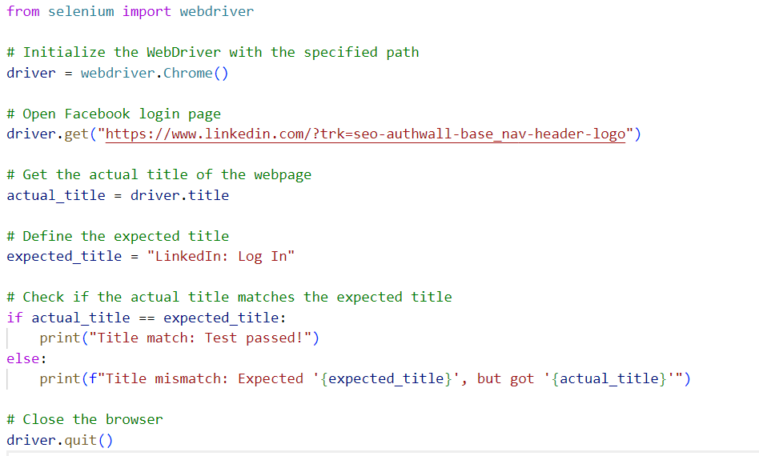

Output:



**Introduction:**

Selenium is an open source testing tool that allows users to test web applications across different browsers and platforms. [Selenium](http://www.seleniumhq.org/) includes a suite of software that developers can use to automate web applications including IDE, RC, WebDriver and Selenium grid, which all serve different purposes

**Postman**

**Introduction:**

Postman is one of the most popular software testing tools which is used for API testing. With the help of this tool, developers can easily create, test, share, and document APIs.

**Use of Postman:**

Almost any functionality that could be needed by any developer is encapsulated in this tool. It is used by over 5 million developers every month to make their API development easy and simple. It has the ability to make various types of HTTP requests(GET, POST, PUT, PATCH), save environments for later use, converting the API to code for various languages(like JavaScript, and Python).

Apart from this, If you want to take out Mocking API and user-friendly API documentation, this article offers an ideal option for you. [Apidog](https://apidog.com/) is a powerful API development tool that connects everyone involved in the API development process. All-in-One workspace for API Design, Documentation, debugging, mocking, test.

**Get Request:**

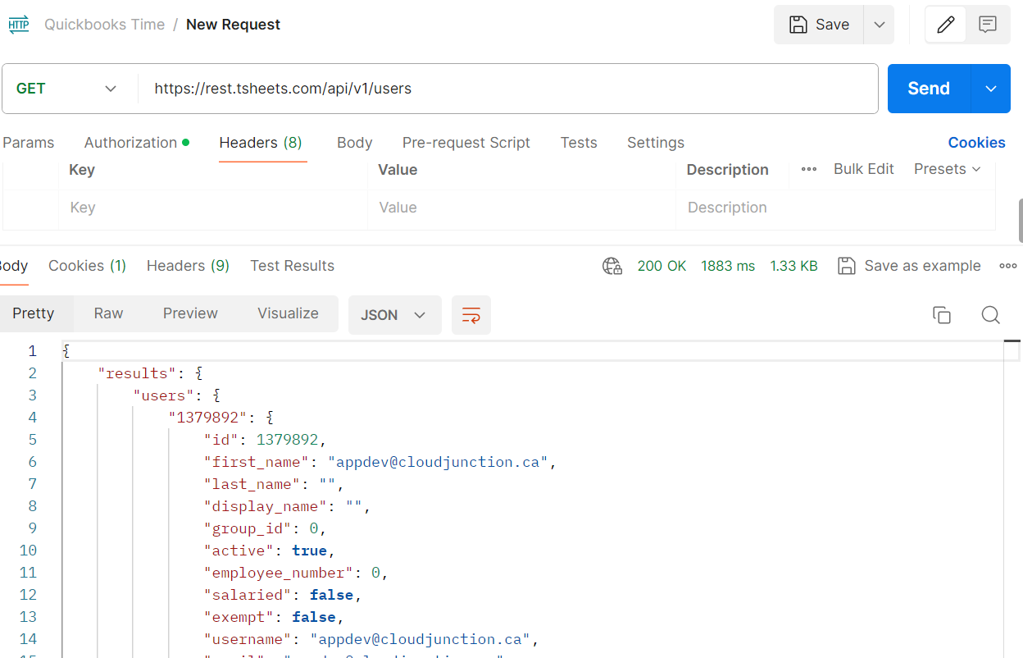

**Post Request:**

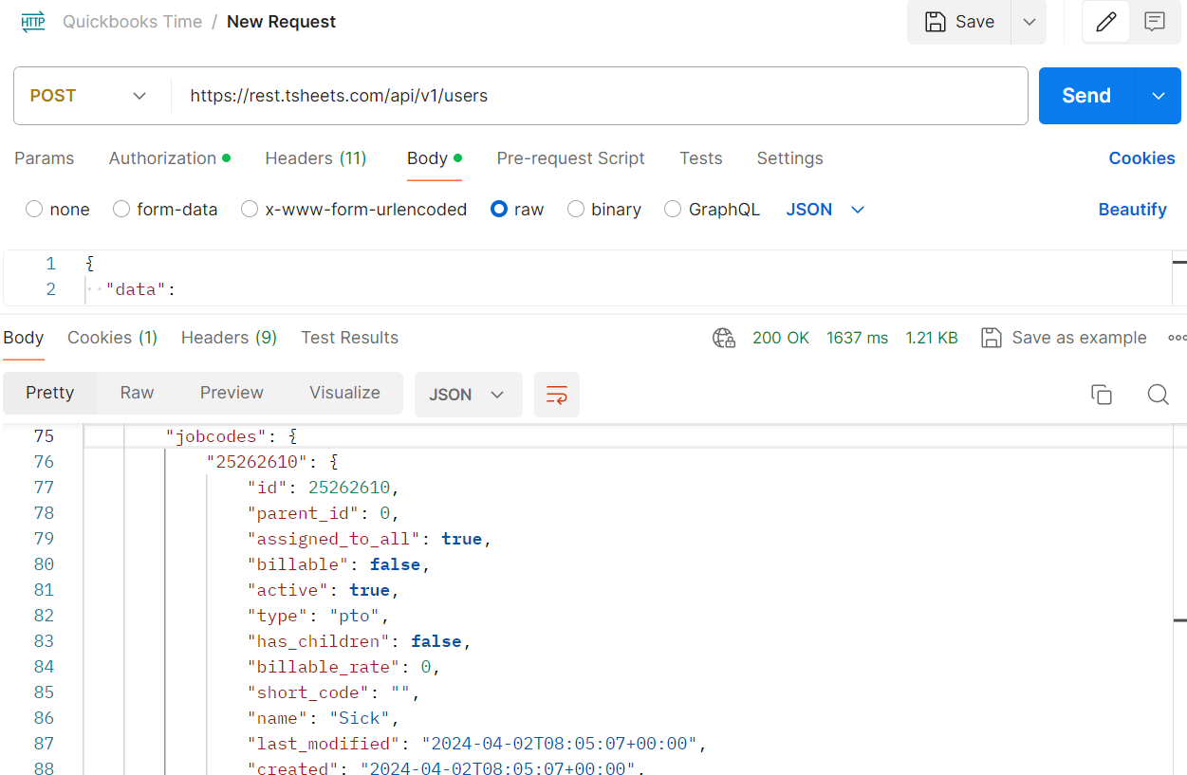

We can also use put, patch, delete and other options but the software I used for accessing records through API does not give the option or allow to use these operations on their records.